**5. JWT-HandsOn**

**Exercise – 1: Create authentication service that returns JWT**

* **pom.xml**

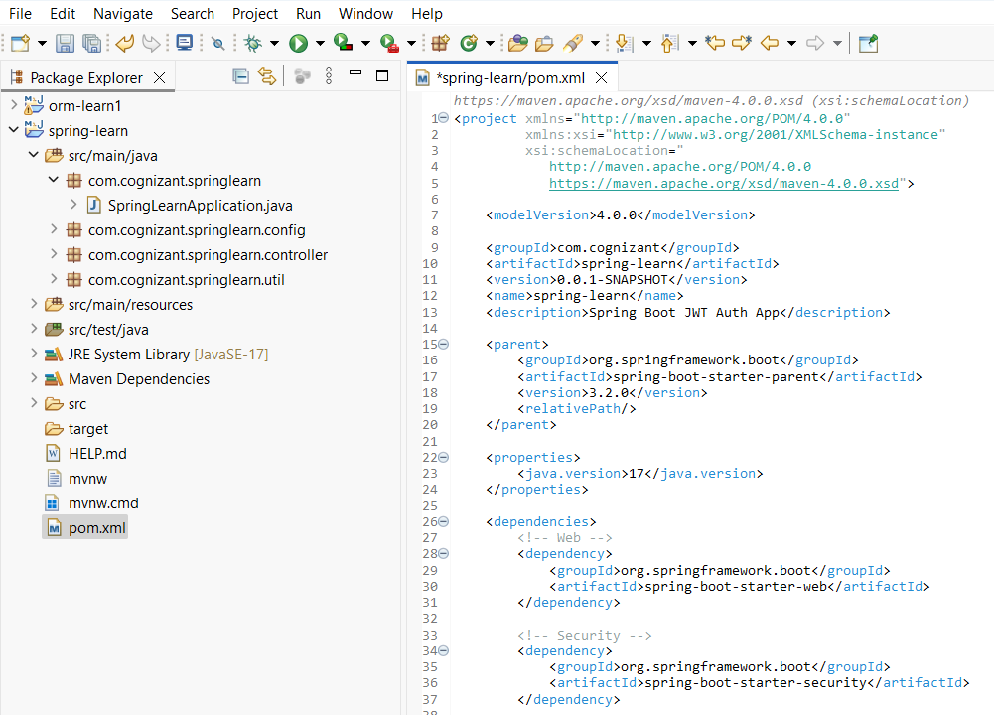

* **com.cognizant.springlearn – SpringLearnApplication.java**

* **com.cognizant.springlearn.config – SecurityConfig.java**

* **com.cognizant.springlearn.controller – AuthenticationController.java**

* **com.cognizant.springlearn.util – JwUtil.java**

* **Console Output**

* **Request Output– “**curl -u "user:pwd" <http://localhost:8080/authenticate>”

